Salt Church – 2026 Men’s Retreat

Where: Pine Summit Bible Camp East 800 Wolf Creek Rd, Prescott, AZ 86303
When: Friday 9/25/26 to Sunday 9/27/26
We're excited to invite the men of Salt Church to our first-ever Men's Retreat, happening September 25th-27th at Pine Summit Bible Camp in Prescott, Arizona. This weekend is designed to help you step away from the pace of everyday life and spend intentional time in God's Word alongside other men.
The retreat will include Bible teaching, outdoor activities, games, fireside worship, and space for personal reflection. It's an opportunity to grow in your faith, build relationships, and return home strengthened as a husband, father, and leader.
Retreat Highlights:
- Registration will currently be capped at 50 and held for attendees of Salt Church
- Cost is $225 and covers all meals and activities
- Carpooling will be encouraged but coordinated at the individual level
- Check-in Friday can take place anytime after Noon and Check out Noon on Sunday
- Friday night Salt Church will cook dinner all other meals will be provided by the camp. Dinner will start at 6PM. Ronnie Ward has the lead…thank him!
- The weekend schedule will have 4 two-hour sessions that will each include worship, a sermon along with small group and large group discussion times.
- Worship is being organized by Jon Racine. Thank you Jon!
- The camp is built for hundreds of attendees. Our church will be the only group at camp so we will have plenty of room to spread out!
- Cody Schulze has taken the lead to put together some organized recreation throughout the weekend. There will be plenty to do!
- There is built in downtime in the schedule to encourage study time and fellowship
- You are adults so we won’t establish a cell phone policy but just keep in mind you will get out what you put in.
- Alcohol…nope.


Packing List:
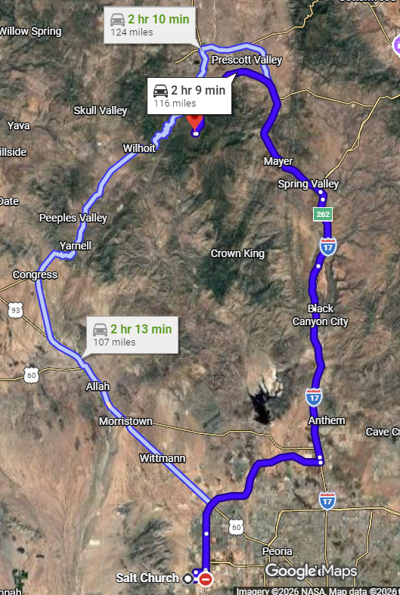
- Bible
- Pillow
- Toiletries
- Towel
- Shower shoes
- Athletic shoe/hiking
- Sleeping bag/blanket
- Medications
- Bible
- Journal/Notebook
- Active clothes
- Snacks
- Water bottle
- Electrolytes
- Coffee cup
- Bug spray
- Sunscreen
- Air pods/ear plugs (some of the men snore
….you know who you are!)
